Park Equity, Life Expectancy, and Power Building Toolkit

Prevention Institute’s Park Equity, Life Expectancy, and Power Building Toolkit is designed to assist community advocates and others make a compelling case for public investments in park infrastructure in high need communities. While the content focuses on the Los Angeles region, the findings and insights included in the toolkit documents are pertinent to communities throughout the U.S.
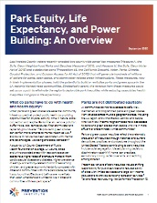
The Overview is a 4-page summary of the project’s research and policy reports. It can be used as a handout to share with decision makers who may prefer briefer documents. For organizing and coalition building purposes, the Overview document can help educate residents, allies and other stakeholders. The Overview is also available in Spanish.
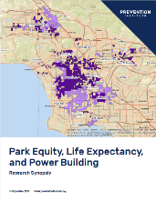
The Research Synopsis describes findings from research on linkages between access to parks and life expectancy at the census tract-level in Los Angeles County. Briefly, increasing park acreage has the potential to increase life expectancy for LA County residents in areas that have less tree cover or lower vegetation levels than the county median. The Research Synopsis and the Policy Brief, described below, can ground readers in critical park equity issues.
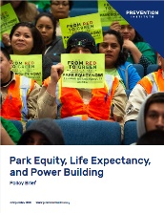
The Policy Brief reviews the literature on the production of park inequities through policies, practices and norms. The Policy Brief can assist groups to analyze park inequities and develop strategies for reversing them. The Policy Brief sets forth 12 policy recommendations that can be adapted to local conditions.
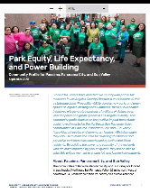
Three community profiles present the research findings for the communities of South Los Angeles, Boyle Heights and unincorporated East Los Angeles and the Northeast San Fernando Valley in Los Angeles. The profiles highlight local park equity work. The three profiles are also available in Spanish.


The Presentation slides and talking points highlight content from the Policy Brief and Research Synopsis. The slides assist groups in efforts to educate residents, staff or allies about park equity issues and make presentations to decision makers.
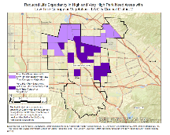
The 31 maps produced for this project are specific to the Los Angeles region. These visuals powerfully convey the park access and life expectancy situation in Los Angeles County as a whole, the five County Supervisorial districts and for the 15 Los Angeles City Council districts. Other maps are also available in the Toolkit, including the United States Small-Area Life Expectancy Project (USALEEP) maps and the LA County Reduced Life Expectancy Map.

